900221-000-00-KM-03, Principles of Programming with Python, NQF Level 4, Credits 4
Facilitator Guide
Module Three (3)

Module Code | 900221-000-00-KM-03
NQF Level | 4
Credits | 4
Skills Programme ID Number | SP- 230375
Curriculum Title | Java Programmer
Curriculum Code | 900221-000-00-00

Name
Contact Address
Telephone (H)
Telephone (W)
Facsimile
Cellular
E-mail

Note to the learner
This Learner Guide provides a comprehensive overview of the module. It is designed to improve the skills and knowledge of learners, and thus enabling them to effectively and efficiently complete specific tasks.

Purpose of the Module
The main focus of the learning in this knowledge module is to build an understanding of the principles of programming with Python programming language
The learning will enable learners to demonstrate an understanding of:
- KM-03-KT01: Making decisions in Python 30%
- KM-03-KT02: Operators 30%
- KM-03-KT03: Functions in Python 15%
- KM-03-KT04: Date, Time and Calendar 15%
- KM-03-KT05: Import, input and output 10%

Provider Accreditation Requirements for the Knowledge Module
Physical Requirements:
- The provider must have lesson plans and structured learning material or provide learners with access to structured learning material that addresses all the topics in all the knowledge modules as well as the applied knowledge in the application.
- QCTO/ MICT SETA requirements

Human Resource Requirements:
Lecturer/learner ratio of 1:20 (Maximum)
- Qualification of lecturer (SME): o NQF 5 qualified in industry recognised qualifications with 1-year experience in the IT industry
- Cybersecurity vendor certification • Assessors and moderators: accredited by the MICT SETA

Legal Requirements:
- Legal (product) licences to use the software for learning and training
- OHS compliance certificate

Venue, Date and Time:
Consult your facilitator should there be any changes to the venue, date and/or time.Refer to your timetable.

Assessments
Integrated Formative Assessment: The skills development provider will use the curriculum to guide them on the stipulated internal assessment criteria and weighting. They will also apply the scope of practical skills and applied knowledge as stipulated by the internal assessment criteria. This formative assessment leads to entrance into the integrated external summative assessment.

Integrated Summative Assessment: An external integrated summative assessment conducted through the relevant QCTO Assessment Quality Partner is required to issue this qualification. The external integrated summative assessment will focus on the exit level outcomes and associated assessment criteria.

Skills Programme Rationale
In South Africa, according to the 2020 list of occupations in high demand: Technical Report (Department of Higher Education and Training) published in 2021 it is clear that the role of the programming and its derived skills programmes have been identified as pivotal by several Sector Education and Training Bodies (SETAs). Responding to the rapid skills demand by supplying Python programmers will thus have a positive impact on the economy.
Python programmers will play a pivotal role in establishing a data-driven culture and currently available advanced technology to manipulate these big data and complex datasets.
It is also important to note that there are great opportunities to become self-employed and the entrepreneurial orientated Python Programmers will form new companies (with the employment creation associated to it).
A demand for competent Python programmers exist in any economic sector, e.g. finance, insurance, healthcare, energy, environmental, government, transportation, agriculture and food. International research also confirms the phenomenal growth in the need for qualified programmers, including Python Programmers.
Typical learners include school leavers and persons who want to enter the ICT sector with programming skills. Minimum requirements are a Gr 11 with Maths Lit and English.

Skills Programme Purpose
A Python Programmer will be able to implement solutions to solve real-life problems in an efficient manner applying a knowledge and understanding of the principles of programming with Python and applicable tools.
Tasks that the learner will be able to know, do and understand after achievement of the skills programme include:
- Create well-written and readable Python programs, using a disciplined coding style, including comments and indentation standards.
- Work collaboratively in a team and execute version control.

Entry Requirements
- Grade 11 with Maths Lit and English.
- Access to equipment, internet connectivity and how to work remotely

EXIT LEVEL OUTCOMES

Exit Level Outcomes (ELO) 1
Describe the basics of Python Programming
Associated Assessment Criteria
- Fundamentals of the Python programming language are explained.
- The basic concepts and methods of object-oriented programming and object-oriented design are described.
- The development life cycle as a means of creating applications is described.

Exit Level Outcomes (ELO) 2
Programme effectively using Python frameworks and functionalities
Associated Assessment Criteria
- The use of Python syntax, using the Python API is applied.
- Well-written and readable Python programs are created, using a disciplined coding style, including documentation and indentation standards.
- The ability to troubleshoot problems with application development is applied.

Exit Level Outcomes (ELO) 3
Work collaboratively in a team using GitHub platform
Associated Assessment Criteria
- An ability to work with Git and GitHub functionalities is demonstrated.
- The ability to work collaboratively in a team using Git is applied
- Version control is executed using Git functionalities such as repositories, branches, commits and pull requests.

Session 1: KM-03-KT01: Making decisions in Python 30%
- IAC0101 Explain the definitions, functions and features of Python loops

In Python, as in many other programming languages, you can make decisions using conditional statements. Conditional statements allow your code to perform different actions based on whether a certain condition is true or false. This is fundamental for creating programs that can adapt and respond to different situations. Here's an overview of the concept, definition, and functions of making decisions in Python:
Concept:
- Making decisions, also known as control flow, is the process of using conditional statements to control the flow of a program based on specific conditions or criteria.
- Conditional statements enable your program to execute different code blocks or statements depending on whether a given condition evaluates to True or False.
Definition:
- In Python, there are primarily two types of conditional statements: if statements and else statements.
Functions:
- if Statements:
  - The if statement is used to execute a block of code if a condition is True. If the condition is False, the code block is skipped.
  - You can use multiple if statements together with elif (else if) and an optional else statement to specify different code blocks for different conditions.
x = 10 if x > 5: print("x is greater than 5") elif x == 5: print("x is equal to 5") else: print("x is less than 5")
- Comparison Operators:
  - Conditional statements often use comparison operators to evaluate conditions. Common comparison operators include == (equal), != (not equal), < (less than), > (greater than), <= (less than or equal to), and >= (greater than or equal to).
age = 18 if age >= 18: print("You are an adult.") else: print("You are not an adult.")
- Logical Operators:
  - Logical operators such as and, or, and not can be used to combine multiple conditions in a single if statement.
grade = 85 if grade >= 70 and grade <= 100: print("You passed the exam.") else: print("You did not pass the exam.")
- Nested if Statements:
  - You can nest if statements inside other if statements to create complex decision-making logic.
x = 10 if x > 5: if x < 15: print("x is between 5 and 15")
Making decisions is a fundamental aspect of programming, and it allows your code to respond dynamically to different scenarios. Conditional statements, comparison operators, logical operators, and nested statements are essential tools for creating decision-making logic in Python programs.

Session 2: KM-03-KT02: Operators 30%
- IAC0201 Describe the definitions, functions and features of Python operators

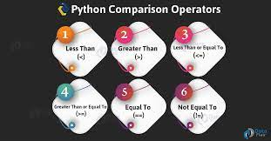
Operators in Python are symbols that represent computations or operations on variables and values. They are fundamental elements of any programming language and are used to manipulate data and perform various tasks. Operators in Python can be categorized into several types based on their functions and behavior. Here's an overview of the concept, definition, and functions of operators in Python:
Concept:
- Operators in Python are special symbols or characters that are used to perform operations on data.
- They are used to manipulate values, perform calculations, make comparisons, and control the flow of a program.
Definition:
- Operators act on operands, which are values or variables on which an operation is performed.
- Operators can be unary (operating on a single operand) or binary (operating on two operands).
Functions of Operators:
Operators in Python serve various functions, and they can be grouped into different categories based on their primary purposes:
- Arithmetic Operators: These operators are used for mathematical calculations.
  - Addition +
  - Subtraction -
  - Multiplication *
  - Division /
  - Modulus % (remainder of division)
  - Exponentiation ** (power)
- Comparison Operators: These operators are used to compare values and return Boolean results (True or False).
  - Equal to ==
  - Not equal to !=
  - Greater than >
  - Less than <
  - Greater than or equal to >=
  - Less than or equal to <=
- Assignment Operators: These operators are used to assign values to variables.
  - Assignment =
  - Addition assignment +=
  - Subtraction assignment -=
  - Multiplication assignment *=
  - Division assignment /=
  - Modulus assignment %=
  - Exponentiation assignment **=
- Logical Operators: These operators are used to perform logical operations and return Boolean results.
  - Logical AND and
  - Logical OR or
  - Logical NOT not
- Bitwise Operators: These operators are used to perform bitwise operations on integers.
  - Bitwise AND &
  - Bitwise OR |
  - Bitwise XOR ^
  - Bitwise NOT ~
  - Left shift <<
  - Right shift >>
- Membership Operators: These operators are used to test whether a value is a member of a sequence or container.
  - Membership in
  - Not membership not in
- Identity Operators: These operators are used to compare the memory address of two objects.
  - Identity is
  - Not identity is not
- Unary Operators: These are operators that operate on a single operand.
  - Unary minus -
  - Unary plus +
  - Logical NOT not
- Ternary Operator (Conditional Operator): The ternary operator is a shorthand way of writing conditional statements.
  - x if condition else y
Operators are essential for performing various operations in Python, and understanding how they work is fundamental to writing effective and efficient code. Different operators serve different purposes and can be combined to achieve complex operations and computations.

Session 3: KM-03-KT03: Functions in Python 15%
- IAC0301 Determine the definitions, functions and features of Python functions

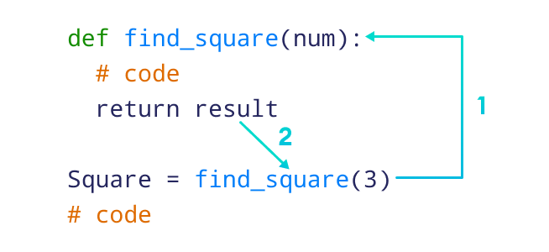
Concept of Functions in Python:
In Python, a function is a reusable block of code that performs a specific task or set of tasks. Functions allow you to break down your code into smaller, more manageable pieces, making your code more organized, modular, and easier to maintain. Functions are a fundamental concept in programming, and they follow a specific structure and set of rules in Python.
Definition of Functions in Python:
A Python function is defined using the def keyword followed by the function name, a pair of parentheses (), and a colon :. The function may take input parameters (arguments) enclosed in the parentheses, and it can optionally return a value using the return statement.
Here's the basic syntax for defining a Python function:
def function_name(parameter1, parameter2, ...): """ Docstring: Optional documentation describing the function. """ # Function body: Code to perform specific tasks # ... # Optional return statement return result
Functions have the following components:
- function_name: The name of the function, which should follow Python naming conventions (e.g., lowercase letters with underscores for readability).
- parameter1, parameter2, ...: Parameters (or arguments) that the function can accept. These are optional.
- Docstring: An optional documentation string (docstring) that provides information about the function's purpose and usage.
- Function body: The actual code that performs the tasks of the function.
- return result: An optional return statement that specifies the value(s) the function should return when it is called.
Functions in Python have several key functions:
- Modularity: Functions allow you to break down complex tasks into smaller, manageable units, making your code more modular and organized.
- Reusability: Once defined, functions can be reused multiple times in your code, reducing redundancy and promoting code reuse.
- Abstraction: Functions abstract the implementation details, allowing you to focus on the high-level logic of your program.
- Parameterization: Functions can accept input parameters, allowing you to pass data to them for processing.
- Return Values: Functions can return values, which can be used in other parts of your code.
- Documentation: Docstrings provide a way to document the purpose and usage of functions, making your code more understandable to others and future you.
Here's a simple example of a Python function:
def greet(name): """ This function greets the user with the provided name. """ message = f"Hello, {name}!" return message
You can call this function by passing a name as an argument, and it will return a greeting message.
greeting = greet("Alice") print(greeting) # Output: Hello, Alice!
Functions are a powerful tool in Python, allowing you to create reusable and organized code, enhancing the maintainability and readability of your programs.

Session 4: KM-03-KT04: Date, Time and Calendar 15%
- IAC0401 Explain the definitions, functions and features of Python date, time and calendar

Concept of Date, Time, and Calendar in Python:
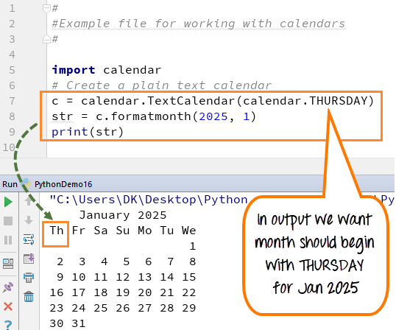
Date, time, and calendar handling in Python involves working with data related to dates, times, and events in a program. Python provides several modules in its standard library to work with these concepts, making it easier to manipulate and display date and time information. Here are the key concepts and modules related to date, time, and calendar in Python:
- Dates: A date represents a specific day in the calendar, typically expressed in the format "YYYY-MM-DD" (year-month-day). Dates are used to represent events, deadlines, and time intervals.
- Times: Times represent specific moments within a day, often specified in hours, minutes, seconds, and microseconds. Times can be used to measure the duration of events or intervals.
- Date and Time: Combining a date and time provides a complete timestamp for a particular moment in time. It is expressed as "YYYY-MM-DD HH:MM:SS.ssssss" (year-month-day hour:minute:second.microsecond).
- Calendar: The calendar includes information about the days, weeks, months, and years. Python provides a calendar module for working with calendars and determining things like day of the week, day of the month, and so on.
- Timezones: Timezones represent regions with a consistent standard time offset from Coordinated Universal Time (UTC). Handling timezones is important when working with date and time information, especially in applications that involve international or multi-timezone data.
Python Modules for Date and Time Handling:
Python provides several modules for working with date, time, and calendar information:
- datetime Module:
  - The datetime module is a versatile module for working with dates and times. It provides classes like datetime, date, time, and timedelta.
  - You can create, manipulate, and format date and time objects using this module.
- time Module:
  - The time module provides functions for working with time-related data, including functions for measuring time intervals and obtaining the current time.
- calendar Module:
  - The calendar module provides functions for working with calendars, including functions to display calendars, determine the day of the week for a given date, and more.
- pytz Module (Third-Party):
  - The pytz library is a third-party library for handling timezones in Python. It provides extensive support for working with timezones and managing date and time information in different regions.
- dateutil Module (Third-Party):
  - The dateutil library is a third-party library that extends Python's datetime module with additional functionality for parsing and formatting dates and times.
- arrow Module (Third-Party):
  - The arrow library is another third-party library that provides enhanced functionality for working with dates and times, including support for timezones and parsing/formatting.
These modules and libraries enable Python programmers to work with date and time information effectively, whether it's for simple date calculations or complex timezone-aware scheduling. The choice of module or library depends on the specific requirements of your project.

Session 5: KM-03-KT05: Import, input and output 10%
- IAC0501 Define the functions and features of Python import, input and output

Concept of Import, Input, and Output in Python:
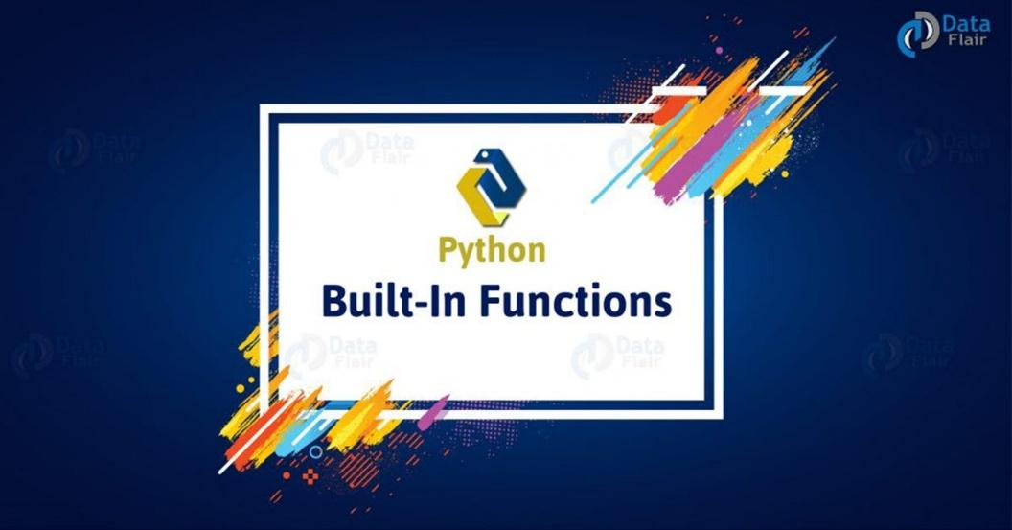
In Python, import, input, and output are fundamental concepts that enable you to interact with external resources, perform computations, and communicate with users. Here's an overview of these concepts:
1. Import:
- Concept: Importing is the process of bringing external modules or libraries into your Python code so that you can use their functions, classes, and variables.
- Definition: Modules are Python files containing Python code. Libraries are collections of modules that provide specific functionalities.
- Functions:
  - import module_name: Imports an entire module.
  - from module_name import function_name: Imports a specific function or variable from a module.
  - import module_name as alias: Imports a module with an alias to simplify referencing.
  - Example: import math or from math import sqrt or import numpy as np
2. Input:
- Concept: Input refers to the process of receiving data from external sources, typically from the user or a file, and making it available for processing in your Python program.
- Functions:
  - input(prompt): Reads a line of text from the user, displaying the optional prompt.
  - Example: name = input("Enter your name: ")
3. Output:
- Concept: Output involves displaying information or results to the user, writing data to files, or sending it to other destinations.
- Functions:
  - print(values): Outputs values to the console.
  - file.write(data): Writes data to a file.
  - sys.stdout.write(data): Writes data to the standard output (console).
  - Example: print("Hello, world!") or file.write("Data to be written to a file")
4. Files:
- Files are a common medium for input and output. You can open, read, write, and close files using Python's built-in file handling functions.
- Functions:
  - open(file_path, mode): Opens a file in a specified mode (e.g., 'r' for reading, 'w' for writing).
  - file.read(): Reads the contents of a file.
  - file.write(data): Writes data to a file.
  - file.close(): Closes a file after reading or writing.
  - Example:
with open('file.txt', 'r') as file: content = file.read()
These concepts are fundamental for building Python programs that interact with external data sources, perform computations, and provide output to users. They enable you to create versatile applications, from simple command-line tools to complex web applications.

